5th July 2018

Dr Eiko Fried,
Assistant Professor
Department of Clinical Psychology, Leiden University

Dear Eiko,
In the matter of James Coyne

I am writing to you in response to your request for information about my experience of interactions with Dr Coyne. I have suffered several years of unpleasant, hectoring and I would say bullying tweets from Coyne, with the consequence that I blocked his Twitter feed on 20th or 21st of February 2017 (I remember the date well because I was attending a conference in Barcelona at the time). This has made it quite difficult for me to find the original tweets that led me to do this, but I have managed to retrieve a few which will hopefully give you some idea of their tone.

I have never encountered Coyne in person but, prior to my encounter with him on Twitter, I had a disagreement with him about the results of one of my colleague’s clinical trials on Keith Law’s website in 2014, which, unfortunately, I have been unable to retrieve. I recall that, at the time, Coyne was quite rude and resorted to boasting about his H-index.

However, my first clash with Coyne on Twitter occurred in February 2016 when I published an article in the Guardian newspaper (Mental illness is a result of misery, yet still we stigmatise it, February 26th 2016) in response to a television programme about mental illness presented by celebrity author, comedian and raconteur Stephen Fry. Briefly, Fry attended the same school as me at about the same time and had (very bravely in my view) used the television programme to talk about his experience of suffering from bipolar disorder. My piece in the Guardian, although highly respectful of Fry, took issue with his biomedical reductionist account of mental illness and pointed out that his own autobiographical writings are consistent with evidence that early life experience plays an important causal role in mental illness.

Coyne’s tweets accused me of being unethical on the grounds that I had diagnosed Fry without his permission (in fact, Fry had reported his diagnosis of bipolar disorder on the television programme and I had not contested it) and of falsely claiming to be a clinical psychologist (In fact, I am fully trained in the UK system, have been teaching on clinical psychology training courses since the late 1980s, but had ceased clinical practice a few years before the exchange). The following will indicate the tone of the exchange:

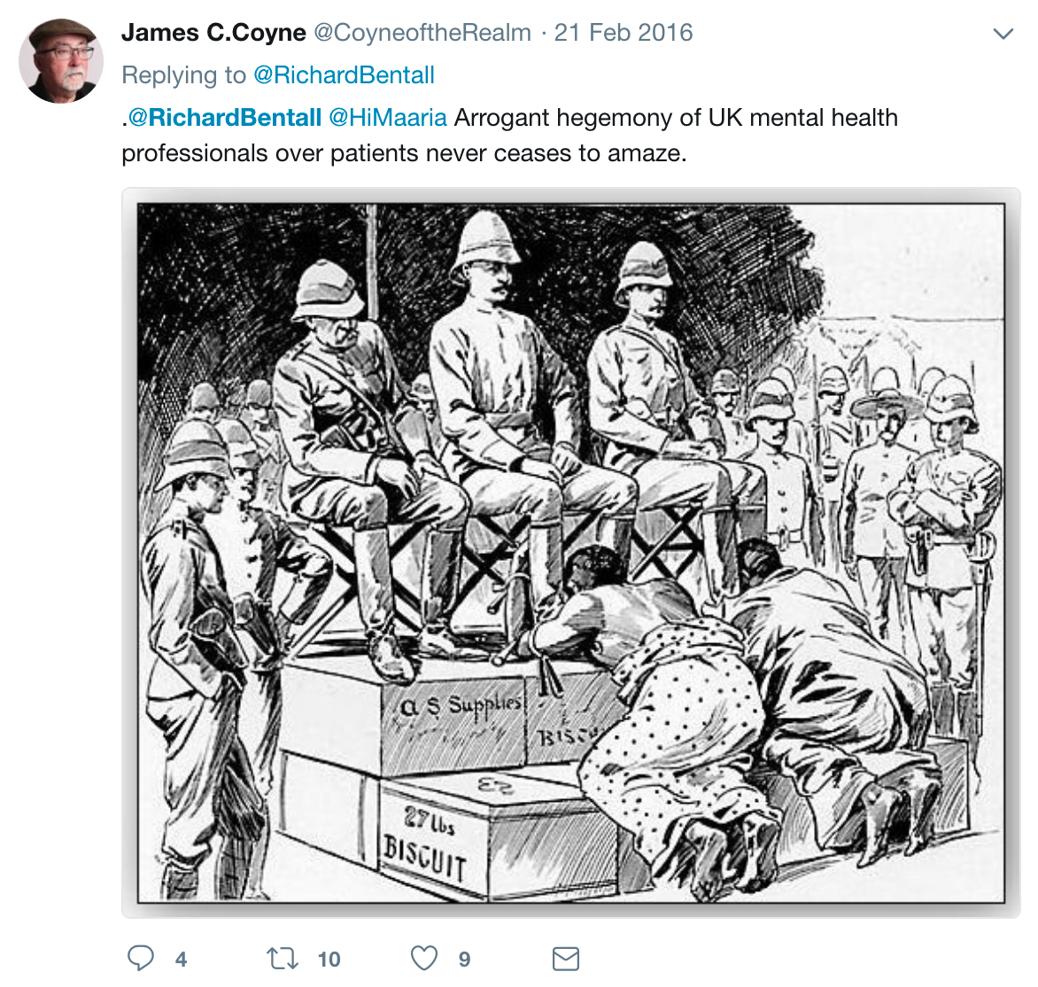

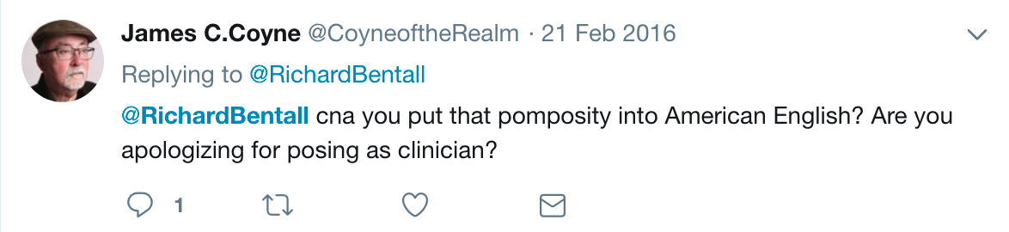

Coyne also similarly berated me in Tweets responding to other Twitter users, for example:

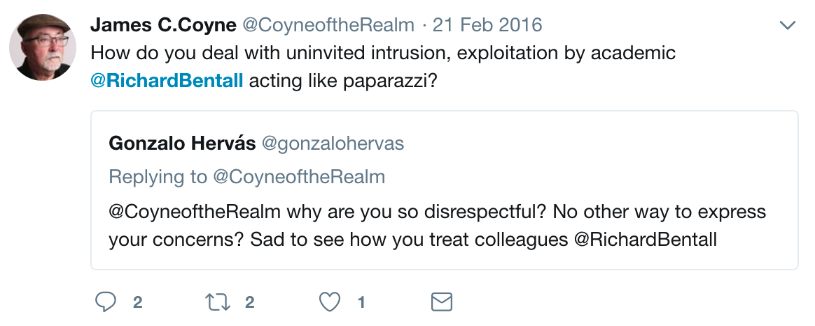

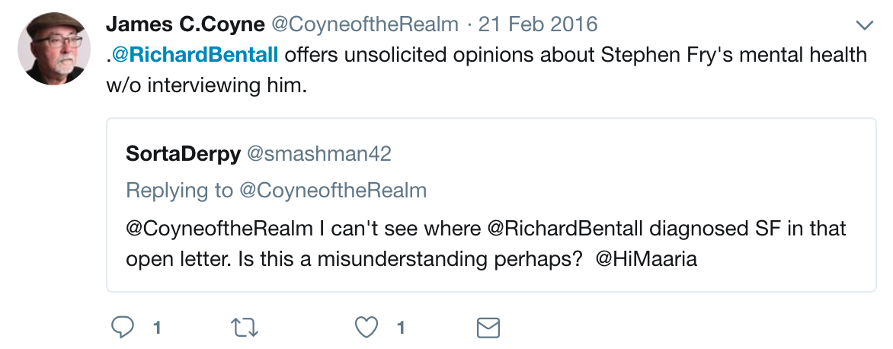

Coyne’s Tweets continued over a number of days, despite my attempts to correct his allegations (easily refuted from open source material) and my demands that he apologise:

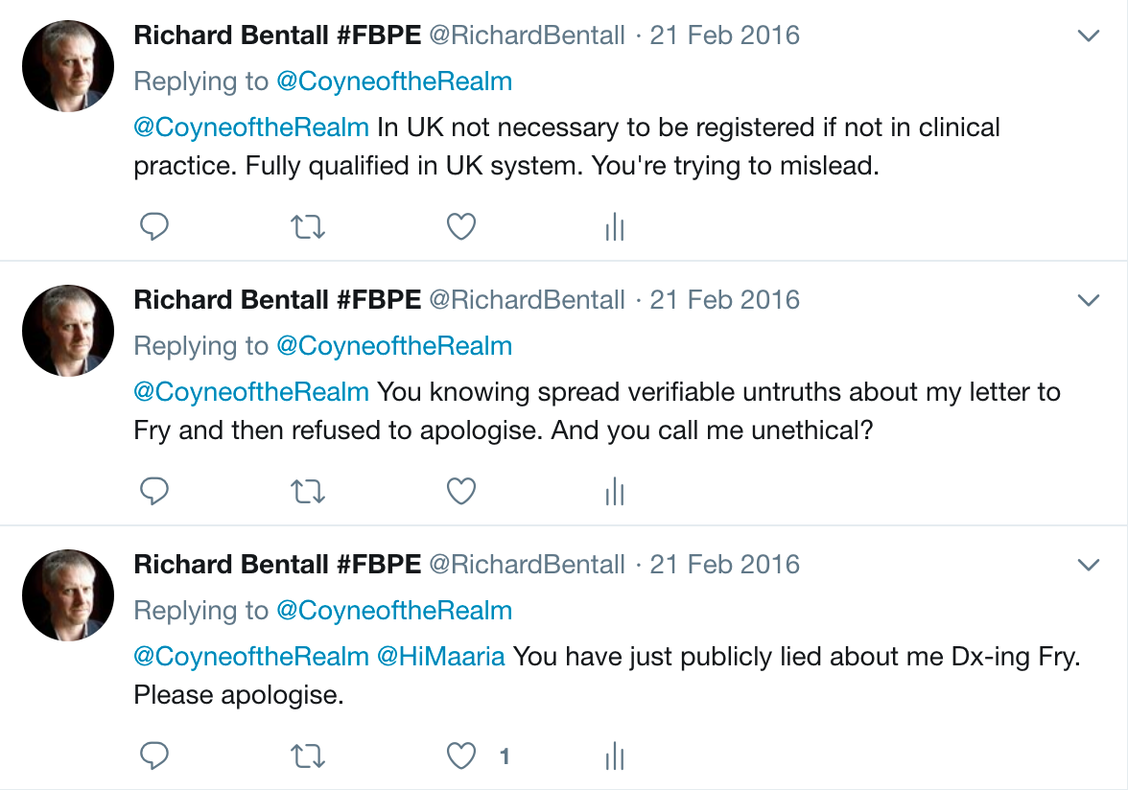

Perhaps I should have blocked him at that point, rather than descend to his level. However, I eventually publically offered him a reward of £1000 if he could prove his allegations:

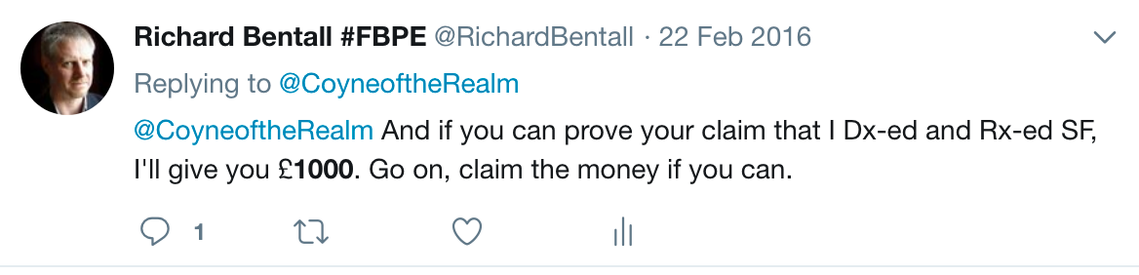

At this point, Coyne bizarrely referred to an earlier malicious allegation he had made against my head of department, Professor Peter Kinderman, claiming that Kinderman had trivialised the Nazi Holocaust:

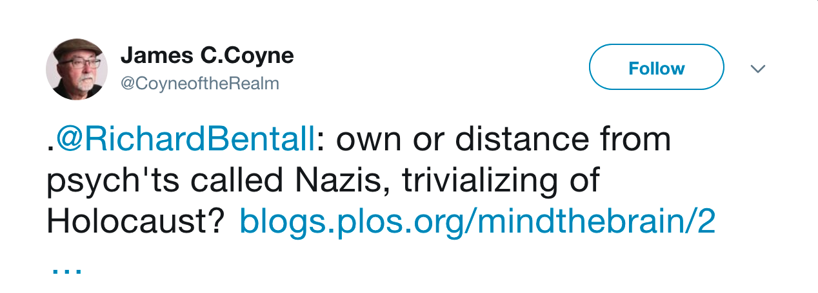

Eventually, in response to my repeated demands that Coyne prove his claims about me his tweets ceased. However, a similarly toned exchange occurred in early 2017, when I tweeted my scepticism about the clinical trials evidence on the effectiveness of electroconvulsive therapy and it was at this point that I decided to block him. While conducting the Twitter search for this letter, I have since discovered that Coyne has continued to take occasional pot shots at me online:

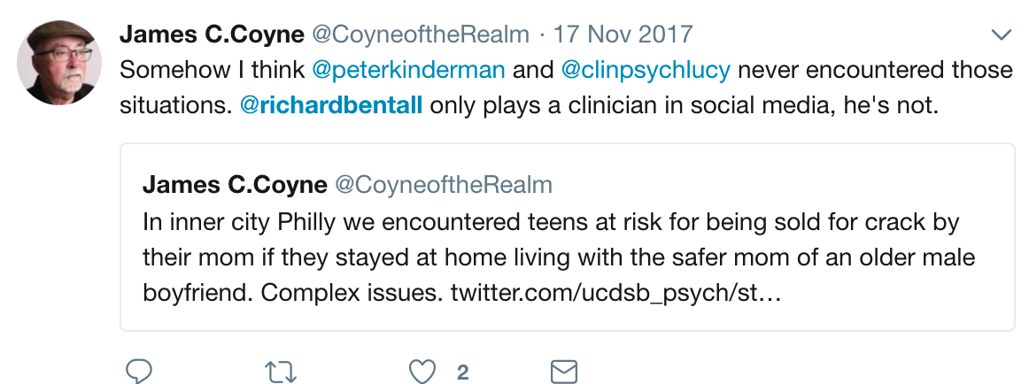

In conclusion, I seem to be one of many UK academics who have been subject to online harassment by James Coyne. This harassment has involved defamatory statements, and indicates a serious lack of professionalism on Coyne’s part. I imagine that some of his Tweets about me would be considered libellous in English law, although I have not sought to take legal action against him thus far.

I am very sorry that you too have been targeted by Coyne. I hope that this letter will provide useful context for your legal team and that you are successful in defending yourself against one of the nastiest and most unpleasant people in the field of psychology.

Sincerely,

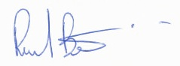

Richard Bentall PhD FBA,
Professor of Clinical Psychology,
Clinical Psychology Unit,
Department of Psychology,
University of Sheffield

